Developmental changes in the precision of visual representations of noun meanings

Abstract
How precise are the visual representations that underlie children’s understanding of words, and how does this precision change across development? We assessed children’s visual representations of noun meanings in a game where children heard a word (e.g., “swordfish”) and had to choose a matching picture from one of four options across a stimulus set of 108 target items. Distractors were chosen to vary in their semantic similarity to each target word in a multimodal language model. We collected data from a large sample of children (N = 3995, 3–14 year olds) and adults (N = 211 adults) and found gradual changes over development in children’s ability to identify the image that a word referred to. When children made errors, younger children were more likely to choose unrelated distractors than older children; error patterns were best explained by a combination of semantic, phonological, and visual similarity. Overall, these findings quantify children’s partial knowledge about many words and document the protracted developmental trajectory for the learning of visual representations of noun meanings.
Keywords: visual concepts, receptive vocabulary, large language models, object recognition
Word count: 2010 excluding Method/Results

Developmental changes in the precision of visual representations of noun meanings

Introduction
Across the world’s languages, many words refer to visible things in the environment (e.g., “thermos”, “prism”, “whale”). How precise are the visual representations that underlie children’s understanding of these words—children’s visual representations of noun meanings? For example, depending on how old a child is (and how much they know about whales) a child might understand that the word whale refers to blue whales—but not whale sharks—or instead only know that a whale is a large animal that lives in the ocean. Children’s acquisition of the boundaries of visual categories and how they map onto words is a key developmental process, as children who lag behind their peers in vocabulary learning are at increased risk for language delays with significant academic and social consequences (Rescorla & Dale, 2013).
Most empirical work on the precision of children’s visual knowledge has focused on the first few years of life, when children learn words at an astonishing rate (Bloom, 2000; Braginsky, Yurovsky, Marchman, & Frank, 2019). In looking-while-listening tasks (Fernald, Zangl, Portillo, & Marchman, 2008), infants as young as 6 months look to pictures associated with common nouns like “bottle” and “banana” (Bergelson & Swingley, 2012), and 14- to 18-month-olds extend newly learned words to atypical exemplars of these categories (Weaver, Zettersten, & Saffran, 2024). By around their second birthday, children also generalize nouns to stylized, 3D exemplars (Pereira & Smith, 2009) as they learn that shape is a valuable cue to basic-level category membership. Empirical work on children’s developing ability to recognize shapes (Ayzenberg & Behrmann, 2024) has also focused on these first few years of childhood as the most important period of rapid developmental change.
An implicit assumption underlying much of this research is that preschoolers and school-aged children’s visual concepts—e.g., their knowledge of what whales “look like” —may not change substantially after they can understand the word “whale” in conversations. On this account, children associate words (e.g., “whale”) with high-fidelity visual information about a particular exemplar (or a few) during learning, and this is sufficient for acquiring the visual concept. Instead, the enrichment for this concept is thought to happen solely at the level of semantics (e.g., “whales eat krill”); on this semantic enrichment hypothesis, later learning during the elementary school years does not influence the content of the visual concepts per se.
Little work has systematically examined how children’s visual representations of noun meanings changes beyond these first few years of life, however. In parallel with acquiring increasingly rich semantic knowledge about the meanings of words, children likely also develop increasingly detailed representations of their visual referents. For example, they might develop a more refined representation of a typical exemplar from a category, and a better understanding of the diagnostic features that distinguish that category from another. Indeed, there is likely an intermediate phase for many words in which children understand, for example, that “whales” are animals that live in the ocean, but have less precision about the visual features that distinguish them from “sharks” and other sea mammals. Classic theories of early word learning have long articulated a view of this type, in which children might initially set up a place-holder concept via “fast mapping” but then gradually fill in later details about the exact perceptual content of this concept (Carey & Bartlett, 1978; Dale, 1965; Swingley, 2010). An example from this early work focused on a case where three-year-olds remembered that a word (“chromium”) was a color word, but they did not know which color it was (Carey & Bartlett, 1978). Theories of later vocabulary acquisition have also characterized children’s word knowledge as progressing through stages (Beck, McKeown, & Omanson, 2014; Dale, 1965), with an intermediate stage where children were thought to have a “vague knowledge of the word’s meaning” (Dale, 1965) before they fully grasp what a word means.
Yet despite this long-standing recognition that children likely have partial word knowledge (Carey & Bartlett, 1978; Dale, 1965), all assessments of receptive vocabulary characterize word knowledge in an all-or-nothing fashion, perhaps because it is indeed difficult to quantify what it would mean to have a low-precision representation for a word. Both direct measures, such as the Peabody Picture Vocabulary Test (Dunn, Dunn, & Bulheller, 2003; Gershon et al., 2014), and parent-report measures of vocabulary knowledge (Fenson et al., 1994; Marchman & Dale, 2023) characterize children as either “knowing” a word or not. Since the distractors for these assessments are chosen carefully, children’s error patterns could in principle reveal evidence for partial knowledge (e.g., selecting a whale shark when the target word is whale), but the datasets resulting from these proprietary assessments are unavailable for re-analysis; the open-source parent-report measures are questionnaires that lack distractors.
In parallel, a large literature on expertise suggests that visual learning almost certainly extends throughout early and middle childhood and into adulthood (Curby & Gauthier, 2010; Harel, 2016) Decades of empirical work has established that birding experts, car aficionados (Tanaka & Gauthier, 1997), and graphic artists (Perdreau & Cavanagh, 2013), among others, have both qualitatively and quantitatively different kinds of visual representations for the visual concepts that they have significant expertise with that is reflected in both behavioral and neural responses. Children’s visual representations are thus likely continually refined throughout early and middle childhood as they acquire expertise and perhaps become experts in their own particular domains (e.g., dinosaurs). More recent developmental work supports this idea (Long, Fan, Huey, Chai, & Frank, 2024): In a large observational study, children became increasingly able to both depict and recognize line drawings of visual concepts (e.g., “whale”, “clock”, “tiger”) from 3-10 years of age, hinting at underlying changes in how children represent the diagnostic features of these visual concepts.
Our empirical and theoretical accounts of the development of children’s visual representations of noun meanings have thus been limited by (1) a need for larger developmental datasets with dense data on individual items and (2) the difficulty of systematically quantifying what it means to have a partial or imprecise representation of a visual concept. Here, we take steps to address both of these challenges. First, we created a new, open-source picture matching task and developed research partnerships with schools across the U.S. in order to gather dense item data across a wide age range (3–14 years) from many children (N=3995 children, N=211 adults). We built a new, open-source “visual vocabulary” task where children heard a word (e.g., “swordfish”) and had to choose a picture in order to teach aliens about their meanings. We then collected data from a large sample of representative children in both online contexts as well as through research-practice partnership with preschools and elementary school contexts across the U.S. Next, we leveraged modern computational models to choose distractor items systematically and to analyze children’s resulting responses, as prior work suggests that similarity metrics derived from model embeddings (low-dimensional vector representations of words or images, where geometric distance approximates similarity in the model’s learned representation space) are strongly (though imperfectly) related to human similarity judgements (Muttenthaler & Hebart, 2021). For each word we chose distractor items that varied in their semantic similarity to the target word as operationalized via the similarity of the target and distractor words in the language encoder of a multimodal language model (Contrastive Language-Image Pre-training model, or CLIP; (Radford et al., 2021)). We then quantified the visual similarity of each target and distractor image using the visual encoder of this model, and used these similarity metrics to analyze variance in children’s error patterns. These advances in data and models thus allow us to quantify changes in the quantity and the precision of children’s visual representations of noun meanings across early and middle childhood.
With these data, we investigated three main questions. First, we examined the trajectory for continual learning of visual representations of noun meanings throughout this age range, highlighting words with more or less variability across age. Second, we examined evidence for changes in the precision of representations before word knowledge is solidified, as per Dale’s (1965) account. If children do not have a visual representation of a word, then they should choose a distractor relatively randomly if they also do not recognise the distractor words; to the extent that children know one or more distractor words, they may systematically avoid those — a contribution we examine via the phonological- and semantic-similarity terms in the error models below. However, if children have some visual knowledge about a word, then we would expect them to systematically choose high-similarity distractors when they do not know the words meaning (e.g., sharks). We thus modeled changes in children’s error patterns across development—asking about the degree to which phonological, semantic, visual, and multimodal similarity metrics between each target and distractor word explained variance. If changes in children’s performance is driven mostly by their knowledge of what visual information “goes with the word”, then a combination of semantic and visual similarity metrics should explain variance in children’s error patterns. In contrast, if children are primarily drawn to visually-similar distractors when they do not know a word’s meaning—irrespective of their semantic similarity to the target word—then visual similarity alone should be a driving factor in error patterns.

Method
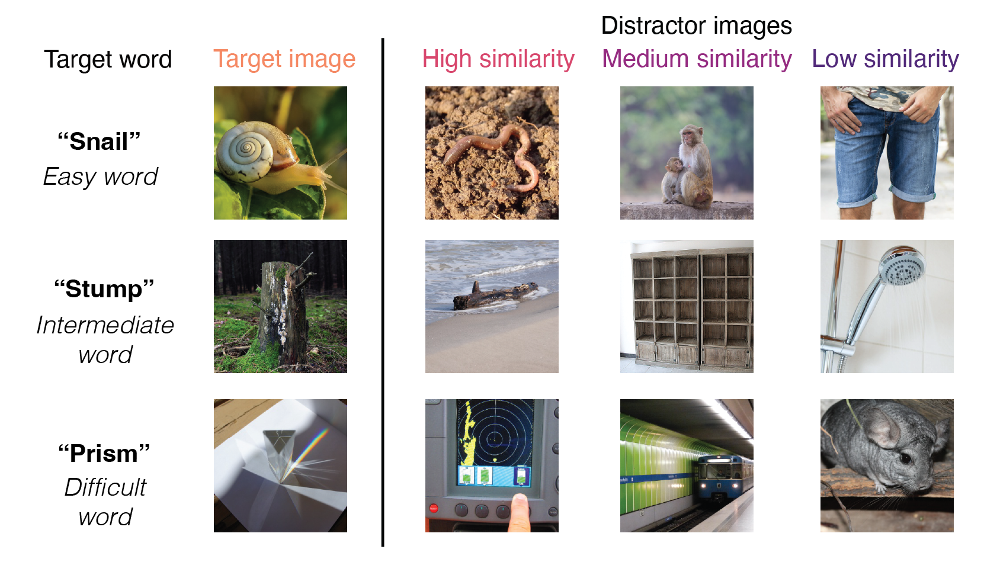
Figure 1. Example trials that depicted easy, intermediate, and difficult words, as operationalized via estimated age-of-acquisition (Kuperman et al., 2012); each target word image is taken from shown alongside the three distractors that varied in similarity to the target word; distractors were chosen via the similarity of the target and distractor words in the language encoder of CLIP (Radford et al., 2021).

Participants
To obtain a large sample of responses for individual items across development, we collected data from children across several different testing contexts, totaling $N$ = 4206 unique participants. We collected data from children in an in-person preschool ($N$ = 65, 3-5 year-olds) and from the Children Helping Science (CHS) Platform ($N$=243, 3-7 year-olds), We also recruited adults online via Prolific; we sampled from monolinguals ($N$=109) and adults who spoke English as a second language ($N$=102) to maximize our chance of finding item variability, and to measure a range of adult abilities.
In addition, we recruited representative samples from schools across the United States through the [BLINDED] platform $N$=3687, 5-14 year-olds) (BLINDED et al.). Schools included seven public or public charter school districts (33 schools), three independent schools focused on supporting students with learning differences, two independent schools, and one summer program. This task was offered as a pilot vocabulary assessment along with other foundational reading measures that were developed for use in school-research partnerships throughout the United States (Coburn & Penuel, 2016; Wentworth, Arce-Trigatti, Conaway, & Shewchuk, 2023).
Most participants responded directly via clicking through the games on a laptop or tapping through the games on a tablet, except those recruited online through CHS and Prolific; children’s parents responded via clicking on the image that the child indicated on CHS, and adults responded via clicking on the images. Children completed, on average, 25.27 distinct target-word trials (SD = 15.85) that were sampled randomly from the stimulus set (maximum = 86; different maximum numbers of trials were included in different testing contexts). All participants who contributed any data were included (minimum trials = 2, maximum trials = 86). Some participants participated in the game more than once ($N$ = 214 children), and their data are included as if they completed additional trials; note that our statistical models include random intercepts for each participant and operate at the trial level; however, excluding these participants did not change the pattern of results.

Materials
We capitalized on publicly available existing image and audio databases to generate trials. Visual concepts were taken from the THINGS+ dataset (Stoinski, Perkuhn, & Hebart, 2024), after filtering out non-child safe images (e.g., weapons, cigarettes) and images with low-nameability (<.3), as per Stoinski et al., 2024. We used the copyright-free, high-quality image released for each visual concept. We subset to visual concepts that had available age-of-acquisition (AoA) ratings from a previous existing dataset (Kuperman, Stadthagen-Gonzalez, & Brysbaert, 2012) where adults were asked to retrospect on the age that they learned a word in development; these estimated AoAs were used as a proxy for item difficulty. Audio for each target word was taken from the MALD database (Tucker et al., 2019).
We used these stimuli to create trials that contained a target image paired with distractor images of similar difficulty (estimated using AoA) and varying similarity (estimated using a computational model). To do so, we sampled distractors with high, medium, and low similarity to the target word as operationalized via the cosine embedding similarity of the words in the language encoder of a multimodal large language model (Radford et al., 2021). We determined high-, medium-, and low-similarity values relative to the distribution of all possible target-distractor similarity values for each word in the THINGS+ dataset. Stimuli were selected so that each target word and each of its three distractor words appeared exactly once in the analysed item set; the sampling procedure maximized the number of trials we could include subject to this uniqueness constraint and the AoA-window constraint described below. in addition, we constrained the sampling such that target-distractor pairs had estimated AoA within 3 years of each other. For each target word, we first selected a high-similarity distractor that had the highest cosine similarity to the target (and was itself not one of the target words). For low-similarity words, we sampled a unique distractor word that had the lowest cosine similarity among the remaining distractors. For medium-similarity distractors, we then randomly sampled a distractor word that was the same animacy as the target word, and unique to the dataset. In our final set, we had 108 items with a range of different estimated age-of-acquisitions (e.g., hedgehog, mandolin, mulch, swordfish, waterwheel, bobsled) with all unique targets and distractors. CLIP visual similarity is computed on the THINGS+ images as released; many stimuli have plain backgrounds, but where backgrounds vary they contribute shared variance to all distractor pairs of a given target and do not bias the within-trial similarity ranking. A foreground-isolation sensitivity analysis confirming this is reported in the supplement (Figure S6). All stimuli and their metadata are available on the public repository for this project (BLINDED).
For modeling item-level variance, we used the word frequency (SUBTLEX) measures taken directly from Stoinski et al., 2024, as well as their aggregated word typicality judgements for the 84/108 target words for which it was available. All stimuli and their metadata are available on the public repository for this project (BLINDED).

Model features
We extracted embeddings for all of the words and the images used in the study in the same multimodal large language model (Radford et al., 2021). This model has both a language and vision encoder and is trained on the contrastive loss between pairs of images and their corresponding captions. In these encoders, each word or image can be represented by a 512 dimensional vector in either semantic or visual similarity space, respectively.
We next computed semantic similarity scores by taking the cosine similarity between the embeddings for each target and distractor word on each trial in the language encoder (e.g., tulip – rose, tulip – glove, tulip – hubcap); this metric calculates the angle between any given two high-dimensional vectors. For visual similarity, we repeated this procedure but by using image similarity vectors from the vision transformer for each target image and distractor image on each trial. For multimodal similarity, we computed the cosine similarity of the embedding of the target word in the language encoder to the embeddings for each of the distractor images in the vision encoder; this is possible because the embedding spaces for the vision and language transformers in this model are aligned and have the same number of dimensions. This procedure thus yielded semantic, visual, and multimodal similarity scores for each target-distractor pairing on each trial. We obtained all model features using https://github.com/openai/CLIP; All code is available on the repository associated with this project.

Procedure
Children were invited to participate in a picture matching game where they were asked to “teach aliens on another planet about some of the words on our planet”; children picked a particular alien to “accompany them on their journey.” Before the images appeared, children heard a target word (e.g., “apple”) and then were asked to “choose the picture that goes with the word”. The four images appeared in randomized locations on the screen, and one of the images always corresponded to the target word (see ). On practice trials, the distractor images were all very dissimilar to the target concept, and the target word was relatively easy. The game played a chime sound if children chose the correct image, and a slightly unpleasant sound if they responded incorrectly; this feedback ensured that children of all ages understood the task correctly. Each child viewed a random subset of the item bank, and the items they viewed were displayed in a random order. Children were allowed to stop the game whenever they wanted to. Different versions of the game included varying amounts of total possible trials and additional items, as these games were developed as part of an additional project to create an open-sourced measure of children’s vocabulary knowledge (Blinded et al., in prep). Here, we analyze children’s responses to items that were generated using the THINGS+ dataset with distractors of varying difficulty (see Stimuli).

Data and code sharing
These data were collected with the secondary goal of creating an open-source measure of children’s developing vocabulary knowledge. These analyses presented in the paper were not pre-registered, and children’s data were analyzed both during and at the end of data collection. All pre-processed data and analysis and plotting code have been made available in an online repository. The raw, trial-by-trial data cannot be shared due to data sharing agreements between the participating schools and the institution’s IRB.

Results
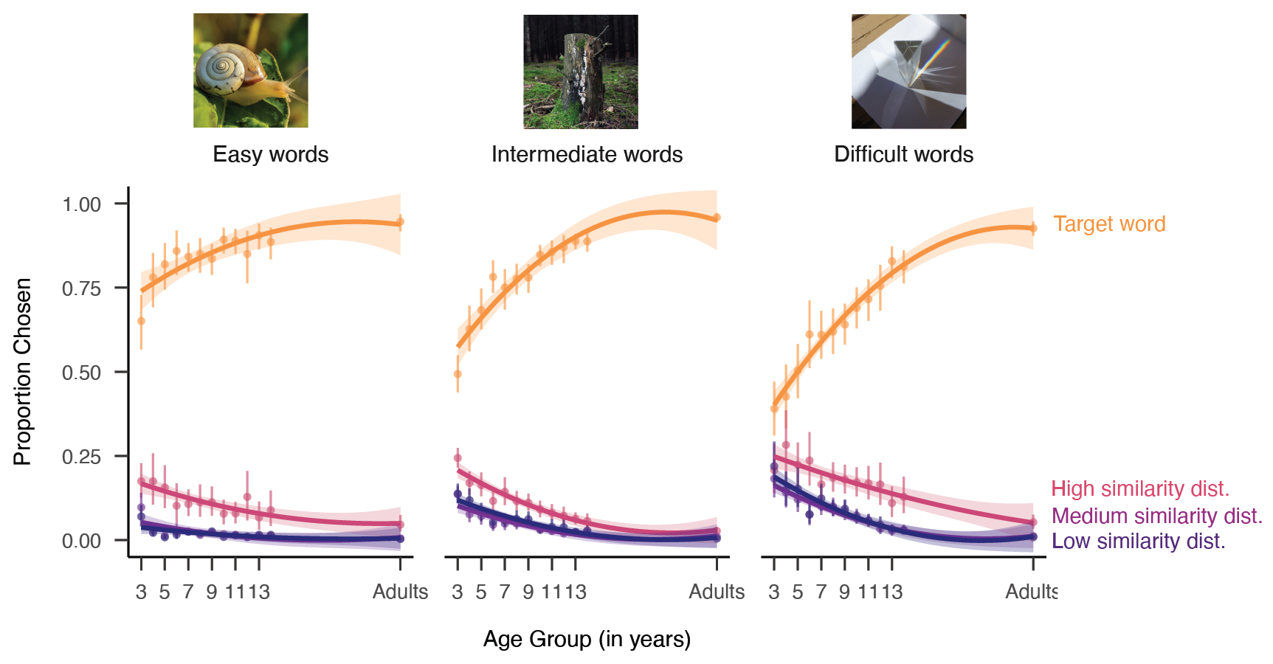
Figure 2. Visual vocabulary task performance as a function of the age of the child completing the task, plotted separately for relatively easy, harder, or difficult words; words are binned into terciles based on the estimated AoA from Kuperman et al., 2012. Lines refer to the proportion of words that children chose the target (orange), high-similarity (pink), medium similarity (purple), or low similarity (dark purple) distractor at each age; error bars represent bootstrapped confidence intervals.

A protracted developmental trajectory
We found a gradual increase across our age groups in how well children could correctly identify the target picture; Figure 2 shows the proportion of time that children identified the target picture, highlighting a protracted developmental trajectory. Older children were more accurate at identifying the correct visual referent that a word referred to, with the oldest children in our sample (13- and 14-year-olds) still performing less accurately than adults.
## # A tibble: 3 × 4
## # Groups: age_group, targetWord [3]
## age_group targetWord perc AoA_Est_Word1
## <dbl> <chr> <dbl> <dbl>
## 1 3 lollipop 0.945 3.89
## 2 3 turtle 0.929 4.17
## 3 3 watermelon 0.929 4.22
## # A tibble: 3 × 4
## # Groups: age_group, targetWord [3]
## age_group targetWord perc AoA_Est_Word1
## <dbl> <chr> <dbl> <dbl>
## 1 3 squirrel 0.782 4.44
## 2 3 map 0.731 5.6
## 3 3 hamster 0.722 4.37
We found a slight developmental trend for relatively easy words that had an average estimated age-of-acquisition (Kuperman et al., 2012) (AoA) of 4.81 years (SD = 0.87; acorn, bulldozer, scoop, puddle, sprinkler), but change over development was much more pronounced for more difficult words (barrel, buffet, coaster, stump, carousel; average AoA = 6.95 years, SD = 0.65) and challenging words (e.g., tapestry, scaffolding, mandolin, aloe; average AoA = 9.60 years, SD = 1.21) (see Figure 2). Statistically, this was reflected as an interaction between estimated AoA and the age group of participants in a linear mixed effect model (see Table 1), where AoA was modeled as a continuous predictor (see data in Supplemental Figure 3). While “easy” words with overall low AoA tended to be words that were relatively concrete and high frequency, these factors did not explain additional variance in children’s overall accuracy.
Table 1
Linear mixed-effect model coefficients predicting the proportion correct for each item in each age group as a function of the frequency, concreteness, typicality, total attempts at the item, estimated AoA of the target word, the age group of the child (in years), and their interaction. All predictors were standardized before analysis.
Term | $\hat{β}$ | 95% CI | $t$ | $df$ | $p$
Intercept | 0.77 | [0.74, 0.79] | 55.99 | 78.06 | < .001
Log. freq. (target) | -0.01 | [-0.05, 0.03] | -0.56 | 77.93 | .575
Concreteness (target) | 0.00 | [-0.03, 0.03] | -0.18 | 78.52 | .861
Typicality | 0.00 | [-0.03, 0.04] | 0.20 | 78.27 | .839
Total attempts | 0.02 | [0.01, 0.03] | 4.77 | 1036.41 | < .001
Age | 0.09 | [0.08, 0.10] | 24.14 | 979.98 | < .001
AoA (target) | -0.08 | [-0.12, -0.05] | -4.44 | 78.03 | < .001
Age × AoA (target) | 0.04 | [0.03, 0.04] | 10.17 | 978.00 | < .001
At an item level, 3-year-olds’ performance on the easiest words (watermelon, M = .93; turtle, M = .93, lollipop, M = .95) suggests that they understood the task. However, other items with relatively low AoAs (squirrel, M = .78, hamster, M = .72; map, M = .73) were more difficult for young children. Over development, the words that showed the greatest change across age (see Figure 3a), included some animals (e.g., swordfish), as well as inanimate objects (prism, antenna, sandbag, turbine) but also other kinds of objects, including parts of buildings (scaffolding, gutter). Some items, however, showed relatively little change across age: these tended to be easy words that children across all ages identified correctly (sunflower, rice, potato, hedgehog). Overall, these results highlight variability across individual items and suggest that children gradually build knowledge of many visual concepts throughout childhood.
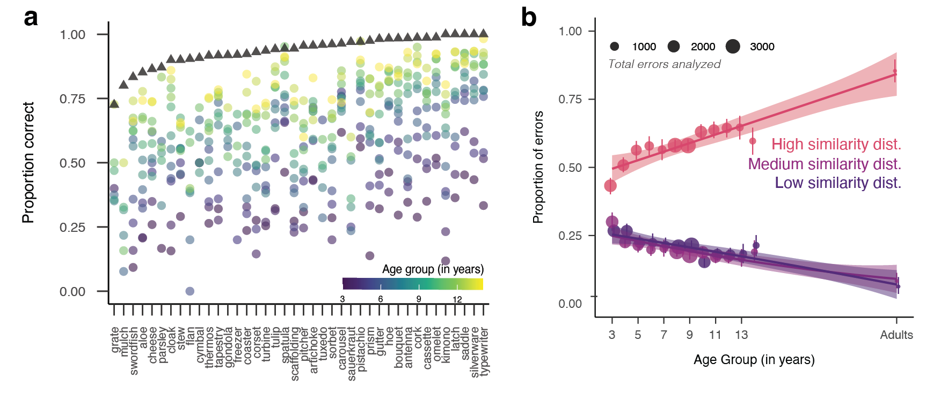
Figure 3. (a) Visualization of the top 30 items that showed the largest differences across age groups; values represent the proportion of correct responses on each target word (e.g., swordfish) within each age group. Triangles represent data from both English monolinguals and second-language learners collected via Prolific. Items are ordered by difficulty for adults. (b) Changes in the proportion of errors chosen as a function of children’s age; pink lines reflect higher similarity distractors. Dot size represents the number of errors made by children in each age group. Error bars represent 95% bootstrapped confidence intervals.

Changes in the precision of visual concepts
Do children begin with high-fidelity representations of what word referents look like or are they acquired more gradually? Thus far, these analyses support a view where children progressively acquire precise visual representations of noun meanings for new words on a relatively long developmental timeline (e.g., visual knowledge that can distinguish between a whale and a whale shark). However, they do not yet provide evidence for the longstanding account that children have partial visual representations of noun meanings that becomes more precise en route to mature word understanding. If children have visual knowledge that is overly broad (e.g., encompassing both whales and sharks), then we would expect children to exclusively choose related distractors (showing evidence of partial knowledge) when they do not know the precise visual meaning of a word. Alternatively, if children quickly acquire relatively high-fidelity representations, then we should only observe changes in how accurate children are at identifying the target word, with no changes in the types of distractors that children choose when they choose incorrectly.
Table 2
Coefficients of a linear regression at the participant level assessing changes in the proportion of related distractors chosen over development. The dependent variable is each participant’s proportion of error trials that fell on the high-similarity (hard) distractor; age and total number of errors were standardized prior to analysis.
Predictor | b | SE | t | p
(Intercept) | 0.61 | 0.00 | 127.67 | < .001
Age | 0.04 | 0.01 | 7.29 | < .001
Total errors | -0.05 | 0.01 | -10.41 | < .001
We thus examined whether there are systematic changes in how children made errors across development, shown in Figure 3b. Consistent with the longstanding view that children have partial knowledge, we found that older children chose more closely related distractors than younger children. Adults were still more likely to choose the related distractors than the oldest children in our sample (14-year-olds) when they made errors. We confirmed this result via a linear regression, modeling the proportion of errors that each child chose related distractors as our dependent variable as a function of children’s age (in years); we also included the number of errors each child made as a covariate as this varied widely by participant and age group. We found a main effect of age (B = 0.04, SE = 0.01, t = 7.29, p < .001): older children were more likely to choose semantically related vs. unrelated distractors. However, we did not find strong differences between distractors that were less related to the target word. We found that both low-similarity and medium-similarity distractors were equally unlikely to be chosen—even though model similarities distinguished these options, children did not. These results suggest that when children know something about the visual meaning of a word, they know enough to reject both the low and medium similarity distractors—e.g., for example, if children have any knowledge of what “whales” are, they know it is not likely to be a cow or an animate household object, but might perhaps confuse it with another sea mammal (see Figure 1). Overall, these results suggest progression where children gradually build up detailed knowledge about the visual referents of many challenging words.

Modeling changes in children’s error patterns
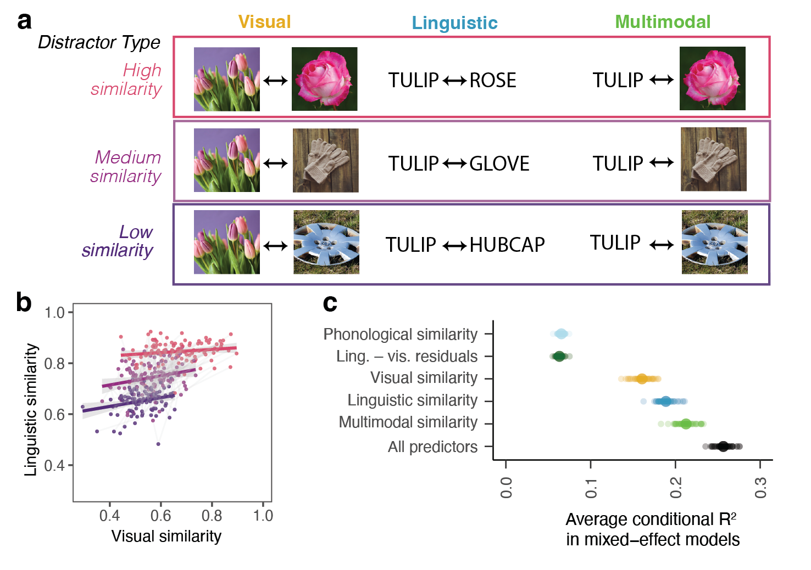
Figure 4. (a) Schematic of the three different ways that embedding similarity was calculated in CLIP (Radford et al., 2021) as a function of the different distractor types. (b) Visualisation of the collinearity between visual and semantic similarity at the item level, with each dot a target-distractor pair coloured by the design’s distractor type. (c) Average explained variance (conditional R²) in children’s error patterns by phonological, residual-semantic, visual, semantic, multimodal, or combined predictors in cross-validated linear mixed-effect models (mean ± bootstrapped 95% CI across 50 random 80% subsamples).
(#tab:modeling table)
model coefficients for the exploratory linear mixed-effect model of error proportions. Predictors include the multimodal similarity (target word to distractor image), the residual of the semantic similarity after regressing on visual similarity (sem_resid; this orthogonalises semantic against visual content rather than entering both raw, given their collinearity at the item level), the phonological similarity, the AoA of the target and answer words, the log frequency of the target and answer words, the concreteness of the target word, the total number of errors per (item, age) cell, the age group of the participant, and the interaction of the residual semantic similarity with age. Random intercepts for target word. All predictors were standardized prior to analysis.
Term | $\hat{β}$ | 95% CI | $t$ | $df$ | $p$
Intercept | 0.33 | [0.32, 0.35] | 47.81 | 82.50 | < .001
AoA (target) | 0.01 | [-0.01, 0.03] | 0.52 | 131.88 | .602
AoA (answer) | 0.01 | [-0.01, 0.02] | 1.09 | 2889.87 | .277
Multimodal sim. | 0.11 | [0.10, 0.12] | 22.14 | 2432.30 | < .001
Semantic residual | 0.03 | [0.02, 0.04] | 5.25 | 1703.15 | < .001
Age | 0.00 | [-0.01, 0.01] | -0.24 | 3980.78 | .809
Phonological sim. | 0.05 | [0.04, 0.06] | 9.53 | 1798.02 | < .001
Log. freq. (target) | 0.00 | [-0.02, 0.02] | 0.09 | 86.06 | .925
Log. freq. (answer) | 0.00 | [-0.01, 0.02] | 0.61 | 2783.88 | .543
Concreteness (target) | -0.01 | [-0.02, 0.01] | -1.18 | 84.23 | .243
Total errors | 0.00 | [-0.01, 0.01] | -0.80 | 1371.92 | .423
Semantic residual × Age | 0.01 | [0.01, 0.02] | 3.68 | 3864.67 | < .001
In a final set of analyses, we aimed to understand the source of changes in children’s error patterns by leveraging similarity metrics derived from a large, multimodal language model (Radford et al., 2021). When we created our stimuli, we paired targets and distractors by using word similarity in a semantic embedding space, but of course the corresponding visual stimuli naturally vary in their visual similarity to each other. This is true both at a category level— that is, animals are more similar visually to each other than to inanimate objects (Kriegeskorte, Mur, & Bandettini, 2008; Long, Störmer, & Alvarez, 2017) but also can be true at an image level—e.g., the flowers in the images of rose and tulip were both pink. Thus, some stimuli on certain trials could be more related to the target concept semantically and less related visually, or vice versa. For example, the words scoop and sauce had high similarity in the language encoder (r = .924), and their corresponding images had lower similarity in the vision encoder (r = .560). Conversely, the words tulip and rose had relatively lower similarity in the language encoder (r = .785) than their corresponding images in the vision encoder (r = .872) (see Figure 4A, Figures 4B). Thus, our large and varied set of stimuli—and the ability to easily parameterize the relative semantic and visual similarity of all target-distractor pairs—affords the opportunity to examine what drives item-level variability in this task. We thus examined the degree to which children’s error patterns reflected changes in how they processed the visual similarity of the targets and distractors, their semantic similarity, or—perhaps most likely—some combination.
To do so, we used a series of cross-validated linear mixed effect models, where we examined the degree to which visual, semantic, and multimodal similarity metrics (and their combination) derived from multimodal large language model embeddings could explain children’s error patterns. Specifically, we modeled the proportion of time that children chose each distractor for a target word as a function of the age (in years) of the children participating, and (1) the similarity of the target word to each distractor word (semantic similarity), (2) the similarity of the target image to each distractor image (visual similarity), and (3) the similarity of the target word to each distractor image (multimodal similarity), and (4) a model with all predictors combined; we additionally added the total number of errors per item as a covariate, with random intercepts for each target word. Because semantic and visual similarity are collinear at the item level (Figure 4B), we also computed a residual semantic-similarity index by regressing semantic similarity on visual similarity and taking the residuals; this index is what enters the full exploratory model in Table 3 in place of raw semantic similarity, and is plotted alongside the raw similarity terms in Figure 4C as “semantic - visual residual” so the two specifications can be compared directly. We iteratively sampled 80 percent of the dataset 50 times, and then evaluated the conditional R-squared for each model for each split; these values are plotted in Figure 4C. These results revealed that combining both the visual and semantic similarity terms—either together in one, large mixed-effect model, or via multimodal embeddings—led to increased explained variance in children’s error patterns. These results thus suggest that changes in children’s error patterns across age are not solely due to changes in children’s ability to reject the distractor images that are visually similar to the target concept. Rather, children’s errors are driven by a combination of both visual and semantic similarity.

Discussion
How does children’s visual representations of noun meanings change across childhood? We collected a large dataset of picture-matching performance in adults and children 3–14 years of age where the distractors were systematically related to the target concept. Children from older vs. younger age groups were more accurate at identifying the referents of words; in addition, older children and adults systematically chose similar vs. dissimilar distractors, suggesting that they had partial knowledge of many difficult words. We found that incorporating the semantic similarity of the target and distractor words and the high-level visual similarity of the referent images best explained children’s error patterns—with additional contributions from the phonological similarity of the target and distractor words. Together, these analyses document gradual changes in visual representations of noun meanings across childhood, with abundant partial knowledge along the way.
These data thus hint at substantial enrichment in children’s existing visual knowledge throughout childhood. Rather than acquiring high-fidelity visual information about a particular exemplar (or a few) during learning, these data highlight that children’s representations are likely refined through iterative, repeated interactions with real-life or depicted versions of many categories in learning contexts. For example, certain visual features may become more salient in children’s representations as children understand their functional roles (e.g., whales have baleen to filter feed) or the degree to which they delineate a category boundary (e.g., between whales and whale sharks). Thus, even after a child can successfully understand a word in a supportive context (i.e., a picture book for young children), their underlying visual representation may still change throughout later childhood (Long et al., 2024) – and may also change as a function of their particular interests or learning experiences. Indeed, while adults likely have precise representations for categories they interact with frequently—such as trees, cups, and cars – they likely cannot distinguish between many categories unless they are relative experts in that particular domain, for example, gazelles vs. antelopes.
These findings thus raise new questions about how exactly children’s representations are changing. For example, if a child picks a related distractor (e.g., shark) when they hear a target word (whale), we cannot tell exactly why from these data. Children’s visual knowledge could be both too narrow – excluding the particular exemplar of the whale that represents the target concept – and also too broad at the same time, including the “shark” as part of the “whale” concept. Future studies that iteratively test the boundaries of individual children’s representations could help delineate the evolving content, how they vary across individuals, and how they change across development (Leon Villagra, Ehrlich, Lucas, & Buchsbaum, 2022).
As the timeline for visual learning extends into middle childhood, so does the scope of their learning environment into educational contexts where children’s learning partners include their peers, teachers, and siblings. Further, throughout this entire developmental age range, children’s individualized interests and active information seeking may influence how they acquire detailed visual representations for words. In these contexts, children likely learn about visual features from generic utterances (e.g., “Tigers have stripes”) (Gelman, Ware, & Kleinberg, 2010), where their semantic learning (e.g., “whales are mammals”) also likely influences which visual features are most prominent in children’s representations. Our theories of visual learning, accordingly, need to expand beyond thinking about how children generalize from labelled groups of exemplars.
There are several limitations to the current work. While we include data from a diverse group of children over a wide developmental age range, our conclusions are drawn from just over one hundred experimental stimuli; expanding the range and diversity of both the participants and items in our study (Henrich, Heine, & Norenzayan, 2010) is necessary to understand the generalizability of these findings. Further, our data are cross-sectional, and thus cannot provide evidence for changes in the precision of representations within individual minds. Longitudinal data could confirm the theories suggested here. Our task also constrained children to a single forced choice on each trial; allowing children to indicate multiple acceptable pictures, as in some related paradigms [@leon2022uncovering], could provide more direct evidence about the breadth of children’s category boundaries — particularly the “too broad” account in which a single concept encompasses multiple referents at once. Finally, our manuscript’s choice of CLIP checkpoint is consistent with prior work showing that OpenCLIP’s similarity to children’s behaviour on this exact task increases over training and tracks an age trajectory [@tan2024devbench], so the developmental signal we report is robust to the specific snapshot of CLIP used.
Nonetheless, the present work highlights the promise of large-scale, online platforms for collecting datasets to examine the development of visual representations of noun meanings, and we hope that future researchers will build upon the paradigm, data, and findings presented here. Our results provide evidence that children have abundant partial knowledge for many words before they learn their precise meanings, and highlight that children’s visual knowledge accumulates gradually throughout middle childhood. More broadly, these results expand the timeline and mechanisms relevant for visual learning.

Acknowledgments
This work was supported by a [BLINDED] to [BLINDED]. We gratefully acknowledge the children, families, and schools who participated in these studies, and members of the [BLINDED] and [BLINDED] labs who provided valuable feedback on the design of these studies. We also thank [BLINDED] for aiding with initial stimuli and task design.

Appendix
Table 3
Average number and SD of completed trials for participants in each age group in the dataset (adults as marked as age group=25).
Age Group (yrs) | Mean Num Trials | SD Num Trials | Participants
3.00 | 56.57 | 31.90 | 84
4.00 | 62.87 | 28.90 | 87
5.00 | 54.44 | 31.55 | 100
6.00 | 45.85 | 30.18 | 116
7.00 | 21.35 | 10.37 | 194
8.00 | 21.38 | 8.28 | 649
9.00 | 19.92 | 7.65 | 740
10.00 | 20.50 | 9.76 | 542
11.00 | 21.63 | 7.49 | 526
12.00 | 22.74 | 6.92 | 489
13.00 | 22.42 | 7.68 | 305
14.00 | 21.89 | 4.98 | 237
25.00 | 36.07 | 1.26 | 211
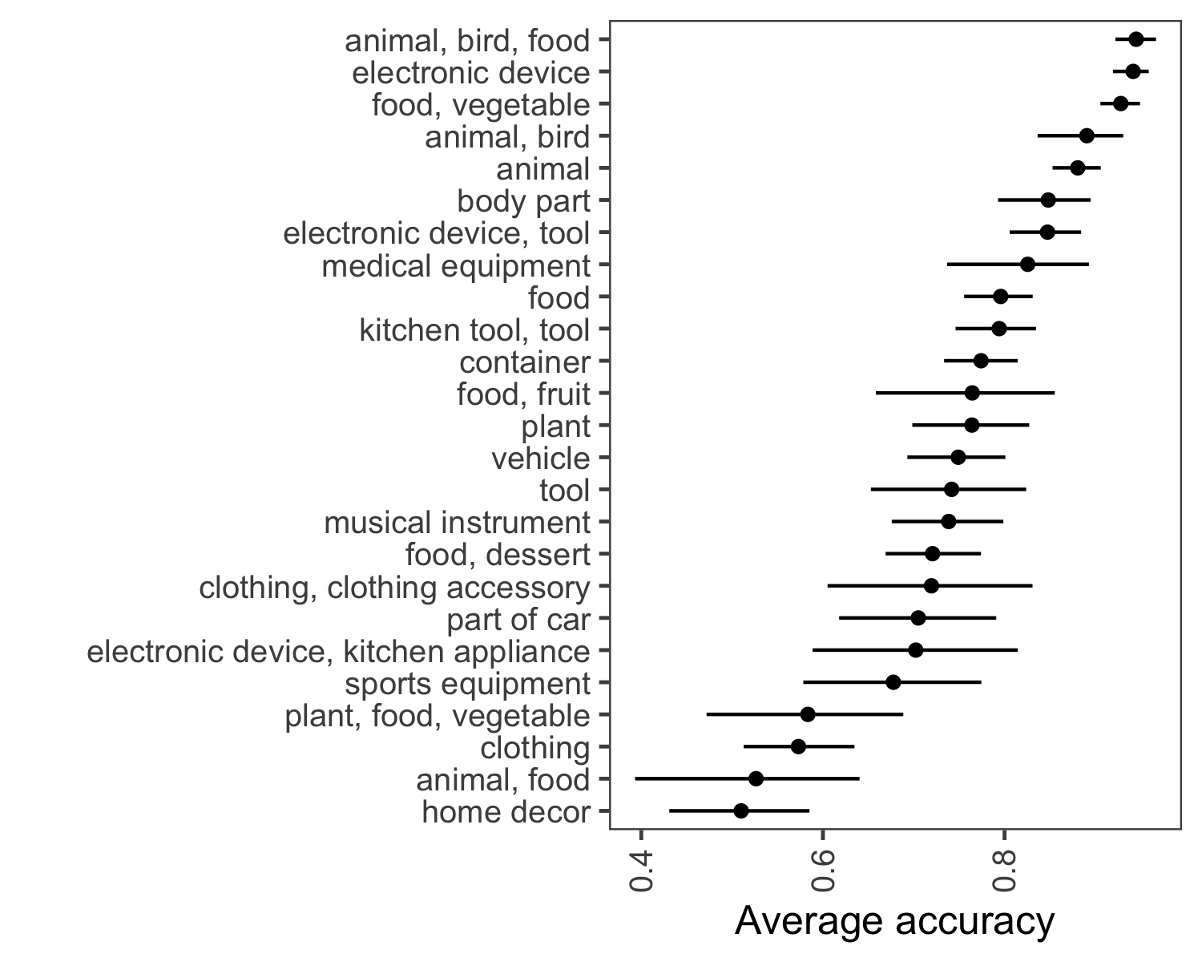
Figure 5. Proportion correct as a superordinate category of the target word, as classified by Stoinski et al., 2023.
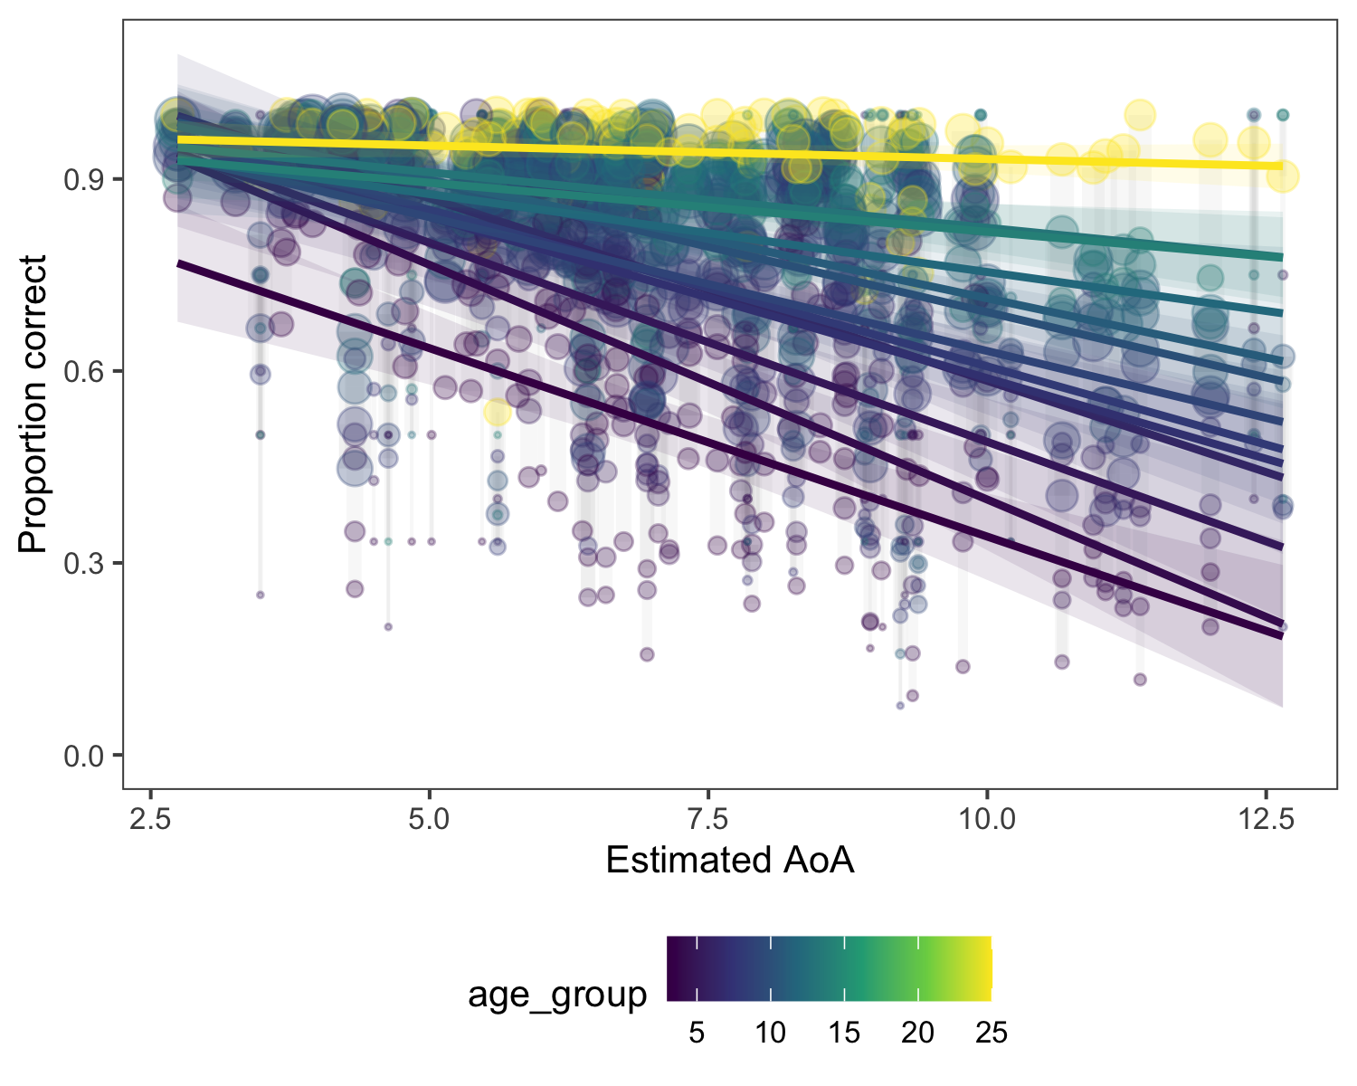 Table: Table 4: Coefficients for the exploratory linear mixed-effect model of error proportions, fit only on child data (age_group < 25). Same specification as Table 3 (multimodal similarity, residual semantic similarity, phonological similarity, AoA target/answer, log frequency target/answer, concreteness, total errors, age, residual semantic × age, random intercept for target word). All predictors were standardized prior to analysis.
Term | $\hat{β}$ | 95% CI | $t$ | $df$ | $p$
Intercept | 0.33 | [0.32, 0.35] | 49.93 | 80.46 | < .001
AoA (target) | 0.00 | [-0.02, 0.02] | 0.39 | 133.47 | .699
AoA (answer) | 0.01 | [0.00, 0.03] | 1.38 | 2555.62 | .167
Multimodal sim. | 0.11 | [0.10, 0.12] | 20.79 | 2089.90 | < .001
Semantic residual | 0.03 | [0.02, 0.04] | 4.56 | 1452.74 | < .001
Age | 0.00 | [-0.01, 0.01] | -0.16 | 3684.42 | .870
Phonological sim. | 0.05 | [0.04, 0.06] | 9.81 | 1532.69 | < .001
Log. freq. (target) | 0.00 | [-0.01, 0.02] | 0.19 | 84.06 | .850
Log. freq. (answer) | 0.00 | [-0.01, 0.02] | 0.73 | 2463.50 | .468
Concreteness (target) | -0.01 | [-0.02, 0.01] | -1.23 | 82.72 | .224
Total errors | 0.00 | [-0.02, 0.01] | -0.85 | 938.71 | .393
Semantic residual × Age | 0.01 | [0.00, 0.01] | 1.30 | 3582.44 | .193
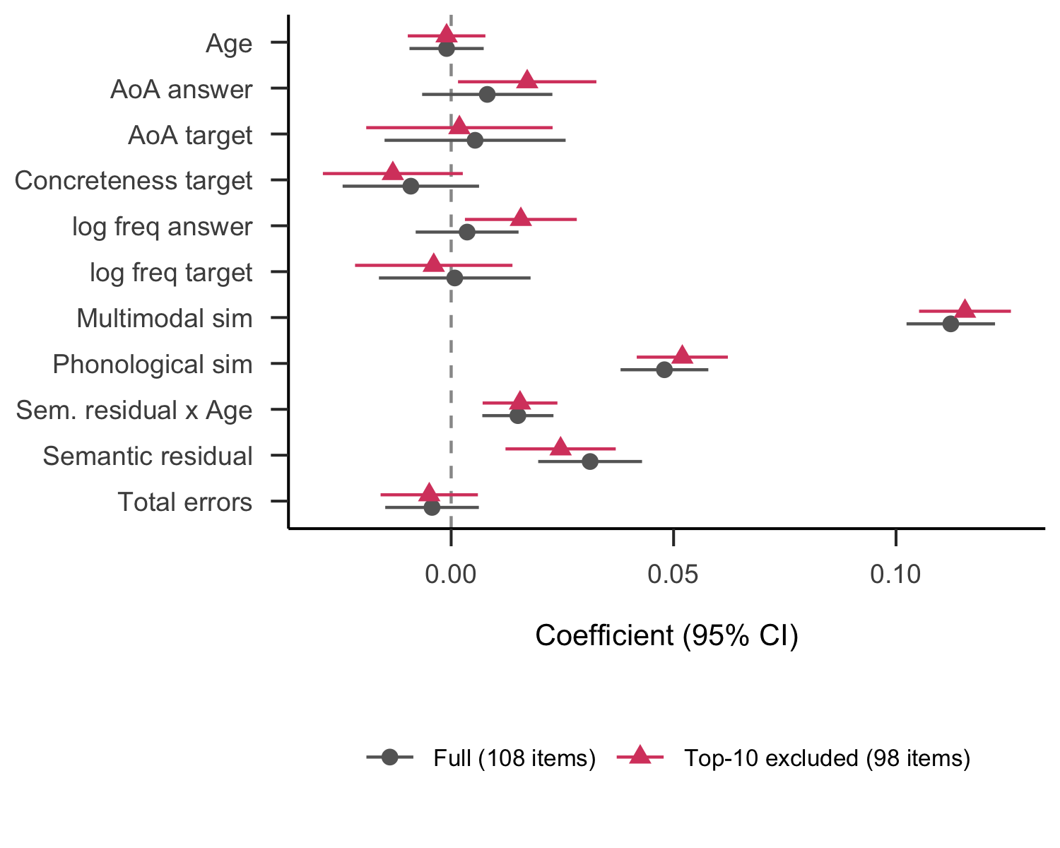
Figure 7. Robustness of the Table 3 model to dropping items with the strongest individual developmental effects. For each of the 108 target items we fit a per-item linear regression of prop_hard on age_group (weighted by total_num_errors per cell) and ranked items by the absolute value of the resulting slope. The Table 3 specification was then refit on (a) all 108 items and (b) the 98 items remaining after dropping the top 10 by slope magnitude (hamster, sandbag, typewriter, lollipop, dumpling, map, tapestry, thermos, waterwheel, puddle). Coefficients overlap closely; the residual-semantic-similarity × age interaction (the load-bearing developmental effect) is preserved (full beta = 0.0150, trimmed beta = 0.0155, both p < .001).
Table 5
Supplementary Table. Linear mixed-effect model of the proportion of errors that fell on the high-similarity distractor, fit on the subset of participants for whom school-type information is available (N = 3,244 rows; 5 school-type categories: bing preschool, independent school, public school, specialized independent school, summer program). The school-type random effect accounts for ICC = 0.017 (1.7% of total residual variance), confirming that school-level clustering does not meaningfully account for variance in the error patterns conditional on age and total error count. Fixed-effect coefficients are essentially unchanged from the equivalent linear regression without the random effect (Table 2). All predictors were standardized prior to analysis.
Term | $\hat{β}$ | 95% CI | $t$ | $df$ | $p$
Intercept | 0.62 | [0.58, 0.66] | 30.76 | 3.01 | < .001
Age | 0.01 | [0.00, 0.02] | 1.78 | 563.55 | .076
Total errors | -0.08 | [-0.09, -0.07] | -15.26 | 3235.63 | < .001
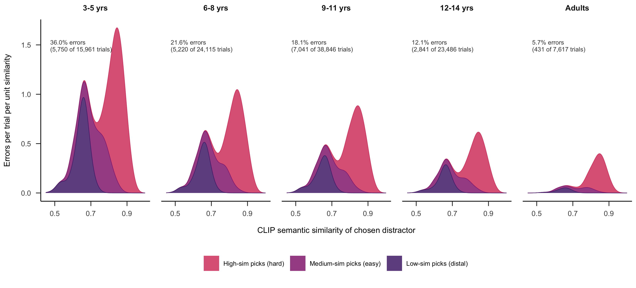
Figure 8. Supplementary Figure. Per-age-band stacked kernel density of the chosen distractor’s CLIP semantic similarity on error trials, decomposed by the design’s wordPairing categories (high / medium / low). Each panel’s area integrates to that age band’s overall error rate, so the dramatic drop in error magnitude from young children to adults (36% to 5.7%) is visible at a glance alongside the within-band shift in composition. The bin locations on the x-axis are stable across age; the developmental story is in (a) shrinking total error rate and (b) increasing share of remaining errors that fall on the high-similarity distractor.
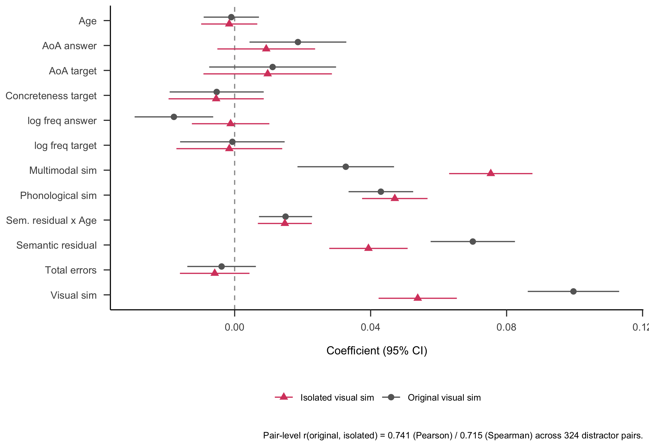
Figure 9. Supplementary Figure. Robustness of the Table 3 model to recomputing CLIP visual similarity on foreground-isolated images. Foreground masks were extracted with rembg (U^2-Net) and the foreground composited onto a flat white background; CLIP ViT-B/32 was then re-run on the isolated images. For 27 of 432 stimuli (mostly texture-dominated images such as ‘mulch’, ‘grain’, ‘quilt’, or thin/partial objects such as ‘ski’, ‘rim’) segmentation produced a degenerate result and the original image was used as the isolated version, so those words contribute the manuscript’s published similarity values to the comparison. Pair-level original and isolated visual similarity correlate at r = 0.74 (Pearson) / 0.72 (Spearman) across 324 distractor pairs. Refitting Table 3 with isolated visual similarity in place of the original (sim_img_img) preserves the qualitative pattern: phonological similarity, AoA, and the residual semantic similarity × age interaction are essentially unchanged; the visual-similarity coefficient shrinks roughly in half (0.10 to 0.05) and the multimodal coefficient grows by a comparable amount (0.03 to 0.08), consistent with shared backgrounds previously contributing to the visual-similarity signal in a way that is redistributed to the multimodal (image-to-text) term once removed. The load-bearing developmental effect (residual semantic similarity × age) is preserved (full beta = 0.015, isolated beta = 0.013, both p < .001).
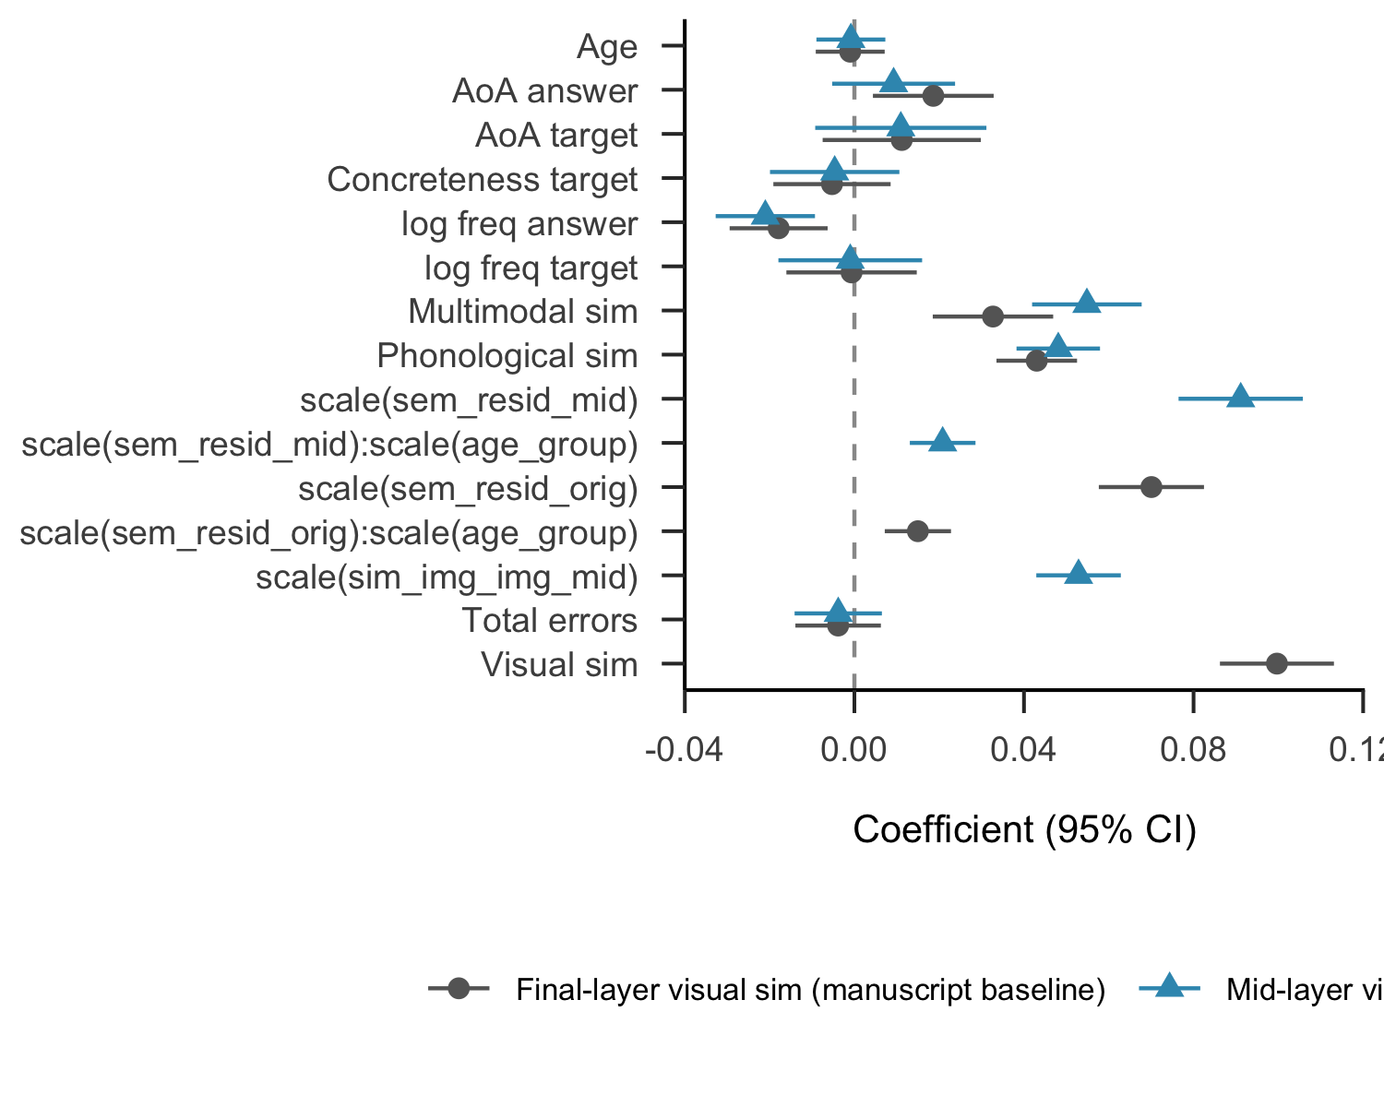
Figure 10. Supplementary Figure. Robustness of the Table 3 model to using a MID-layer visual-similarity index instead of the final projected CLIP embedding. We extracted the CLS-token cosine similarity between target and distractor images at every transformer block of the CLIP ViT-B-32 vision encoder (12 blocks plus the final projection). All blocks were tested by refitting the Table 3 specification with that block’s image-image similarity in place of sim_img_img and re-residualising sim_txt_txt against it. Late-layer visual similarity is highly correlated with semantic similarity (r = 0.54 at the final transformer block; CLIP’s contrastive objective deliberately aligns the two encoders at the projection head), which compresses the variance of the semantic-residual term and makes the residualisation strategy capture less independent semantic content. Mid-layer features (block 6 shown here) preserve the dissociation: visual-semantic correlation is r = 0.14, leaving meaningful independent variance in the residual. The mid-layer specification yields the largest sem_resid × age likelihood-ratio test statistic (chi-square = 28.5, p < 1e-7 at block 4; vs chi-square = 13.3, p < .001 at the final layer), making the developmental semantic-beyond-visual interaction most clearly identifiable. Coefficients overlap closely with the manuscript baseline; all main effects retain direction and significance; the residualisation move is more interpretable when applied to mid-layer visual similarity. Per-layer fits and the variance-components rationale are in the analysis repository (analysis/clip_layer_summary.csv).

References
Ayzenberg, V., & Behrmann, M. (2024). Development of visual object recognition. Nature Reviews Psychology, 3(2), 73–90. https://doi.org/10.1038/s44159-023-00266-w
Beck, I. L., McKeown, M. G., & Omanson, R. C. (2014). The effects and uses of diverse vocabulary instructional techniques. In The nature of vocabulary acquisition (pp. 147–163). Psychology Press.
Bergelson, E., & Swingley, D. (2012). At 6–9 months, human infants know the meanings of many common nouns. Proceedings of the National Academy of Sciences, 109(9), 3253–3258.
Bloom, P. (2000). How children learn the meanings of words. Boston, MA: MIT Press.
Braginsky, M., Yurovsky, D., Marchman, V. A., & Frank, M. C. (2019). Consistency and variability in word learning across languages. Open Mind, 3, 52–67. https://doi.org/https://doi.org/10.1162/opmi_a_00026
Carey, S., & Bartlett, E. (1978). Acquiring a single new word. ERIC.
Coburn, C. E., & Penuel, W. R. (2016). Research–practice partnerships in education: Outcomes, dynamics, and open questions. Educational Researcher, 45(1), 48–54.
Curby, K. M., & Gauthier, I. (2010). To the trained eye: Perceptual expertise alters visual processing. Topics in Cognitive Science, 2(2), 189–201.
Dale, E. (1965). Vocabulary measurement: Techniques and major findings. Elementary English, 42(8), 895–948.
Dunn, L. M., Dunn, D. M., & Bulheller, S. (2003). Peabody picture vocabulary test: PPVT. Swets Test Services.
Fenson, L., Dale, P. S., Reznick, J. S., Bates, E., Thal, D. J., Pethick, S. J., … Stiles, J. (1994). Variability in early communicative development. Monographs of the Society for Research in Child Development, i–185.
Fernald, A. E., Zangl, R., Portillo, A. L., & Marchman, V. A. (2008). Looking while listening: Using eye movements to monitor spoken language comprehension by infants and young children. In Developmental psycholinguistics: On-line methods in children’s language processing (pp. 97–135). John Benjamins Publishing Company.
Gelman, S. A., Ware, E. A., & Kleinberg, F. (2010). Effects of generic language on category content and structure. Cognitive Psychology, 61(3), 273–301.
Gershon, R. C., Cook, K. F., Mungas, D., Manly, J. J., Slotkin, J., Beaumont, J. L., & Weintraub, S. (2014). Language measures of the NIH toolbox cognition battery. Journal of the International Neuropsychological Society, 20(6), 642–651.
Harel, A. (2016). What is special about expertise? Visual expertise reveals the interactive nature of real-world object recognition. Neuropsychologia, 83, 88–99.
Henrich, J., Heine, S. J., & Norenzayan, A. (2010). Most people are not WEIRD. Nature, 466(7302), 29–29.
Kriegeskorte, N., Mur, M., & Bandettini, P. (2008). Representational similarity analysis–connecting the branches of systems neuroscience. Frontiers in Systems Neuroscience, 2.
Kuperman, V., Stadthagen-Gonzalez, H., & Brysbaert, M. (2012). Age-of-acquisition ratings for 30,000 english words. Behavior Research Methods, 44(4), 978–990.
Leon Villagra, P., Ehrlich, I., Lucas, C., & Buchsbaum, D. (2022). Uncovering childrens’ category representations with MCMCP. Proceedings of the Annual Meeting of the Cognitive Science Society, 44.
Long, B., Fan, J. E., Huey, H., Chai, Z., & Frank, M. C. (2024). Parallel developmental changes in children’s production and recognition of line drawings of visual concepts. Nature Communications, 15(1), 1191.
Long, B., Störmer, V. S., & Alvarez, G. A. (2017). Mid-level perceptual features contain early cues to animacy. Journal of Vision, 17(6), 20–20.
Marchman, V. A., & Dale, P. S. (2023). The MacArthur-bates communicative development inventories: Updates from the CDI advisory board. Frontiers in Psychology, 14, 1170303.
Muttenthaler, L., & Hebart, M. N. (2021). THINGSvision: A python toolbox for streamlining the extraction of activations from deep neural networks. Frontiers in Neuroinformatics, 15, 679838.
Perdreau, F., & Cavanagh, P. (2013). The artist’s advantage: Better integration of object information across eye movements. I-Perception, 4(6), 380–395.
Pereira, A. F., & Smith, L. B. (2009). Developmental changes in visual object recognition between 18 and 24 months of age. Developmental Science, 12(1), 67–80.
Radford, A., Kim, J. W., Hallacy, C., Ramesh, A., Goh, G., Agarwal, S., et al.others. (2021). Learning transferable visual models from natural language supervision. International Conference on Machine Learning, 8748–8763. PmLR.
Rescorla, L., & Dale, P. (2013). Late talkers. Brookes, Baltimore. Late Talking Toddlers, 6, 219–240.
Stoinski, L. M., Perkuhn, J., & Hebart, M. N. (2024). THINGSplus: New norms and metadata for the THINGS database of 1854 object concepts and 26,107 natural object images. Behavior Research Methods, 56(3), 1583–1603.
Swingley, D. (2010). Fast mapping and slow mapping in children’s word learning. Language Learning and Development, 6(3), 179–183.
Tanaka, J., & Gauthier, I. (1997). Expertise in object and face recognition. Psychology of Learning and Motivation, 36, 85–126.
Tucker, B. V., Brenner, D., Danielson, D. K., Kelley, M. C., Nenadić, F., & Sims, M. (2019). The massive auditory lexical decision (MALD) database. Behavior Research Methods, 51(3), 1187–1204.
Weaver, H., Zettersten, M., & Saffran, J. R. (2024). Becoming word meaning experts: Infants’ processing of familiar words in the context of typical and atypical exemplars. Child Development, 95(5), e352–e372.
Wentworth, L., Arce-Trigatti, P., Conaway, C., & Shewchuk, S. (2023). Brokering in education research-practice partnerships: A guide for education professionals and researchers. Taylor & Francis.

Words that were learned earlier tended to be more concrete and also more frequent in the English language; however, estimated AoA was collinear with concreteness ratings (correlation between concreteness of the target word and estimated AoA, r = -0.40) and word frequency (correlation between the log frequency of the target word and estimated AoA, r = -0.56). When all three predictors (AoA, concreteness, frequency) were entered into the same linear mixed-effect model, only AoA explained significant additional variance.

